Module Name: Dynamic Controls
Test Case ID: 183
Webpage URL: https://the-internet.herokuapp.com/

● Scenario ID: 12a
Scenario: Add and Remove Elements
Test Steps:
- Open the PyCharm
- Open the existing Python automation project
- Open the Python script
- Run the Selenium automation script
- Open The Internet website
- Navigate to Add/Remove Elements
- Click the Add Element button
- Verify that a Delete button appears
- Click the Delete button
- Verify that the Delete button is removed
- Display the test result
- Close the browser

Screenshots:
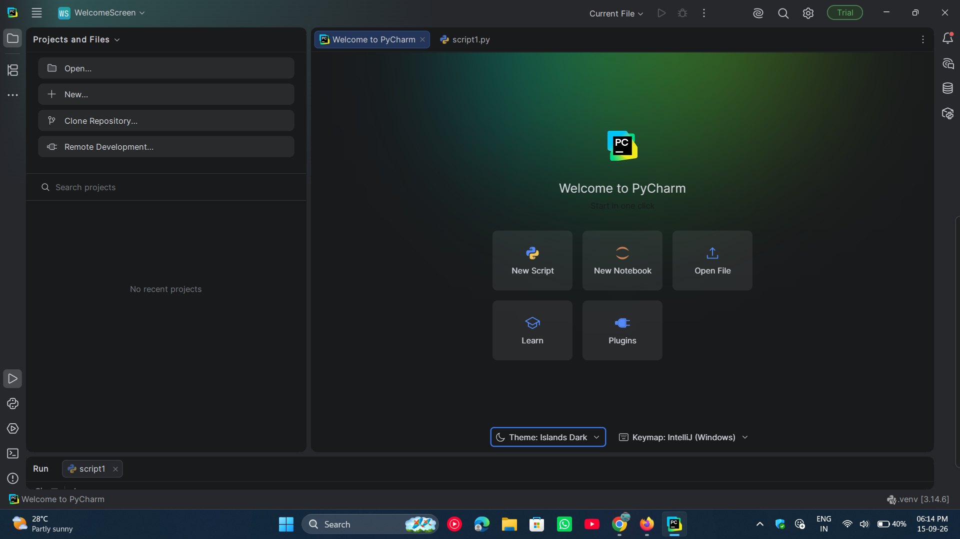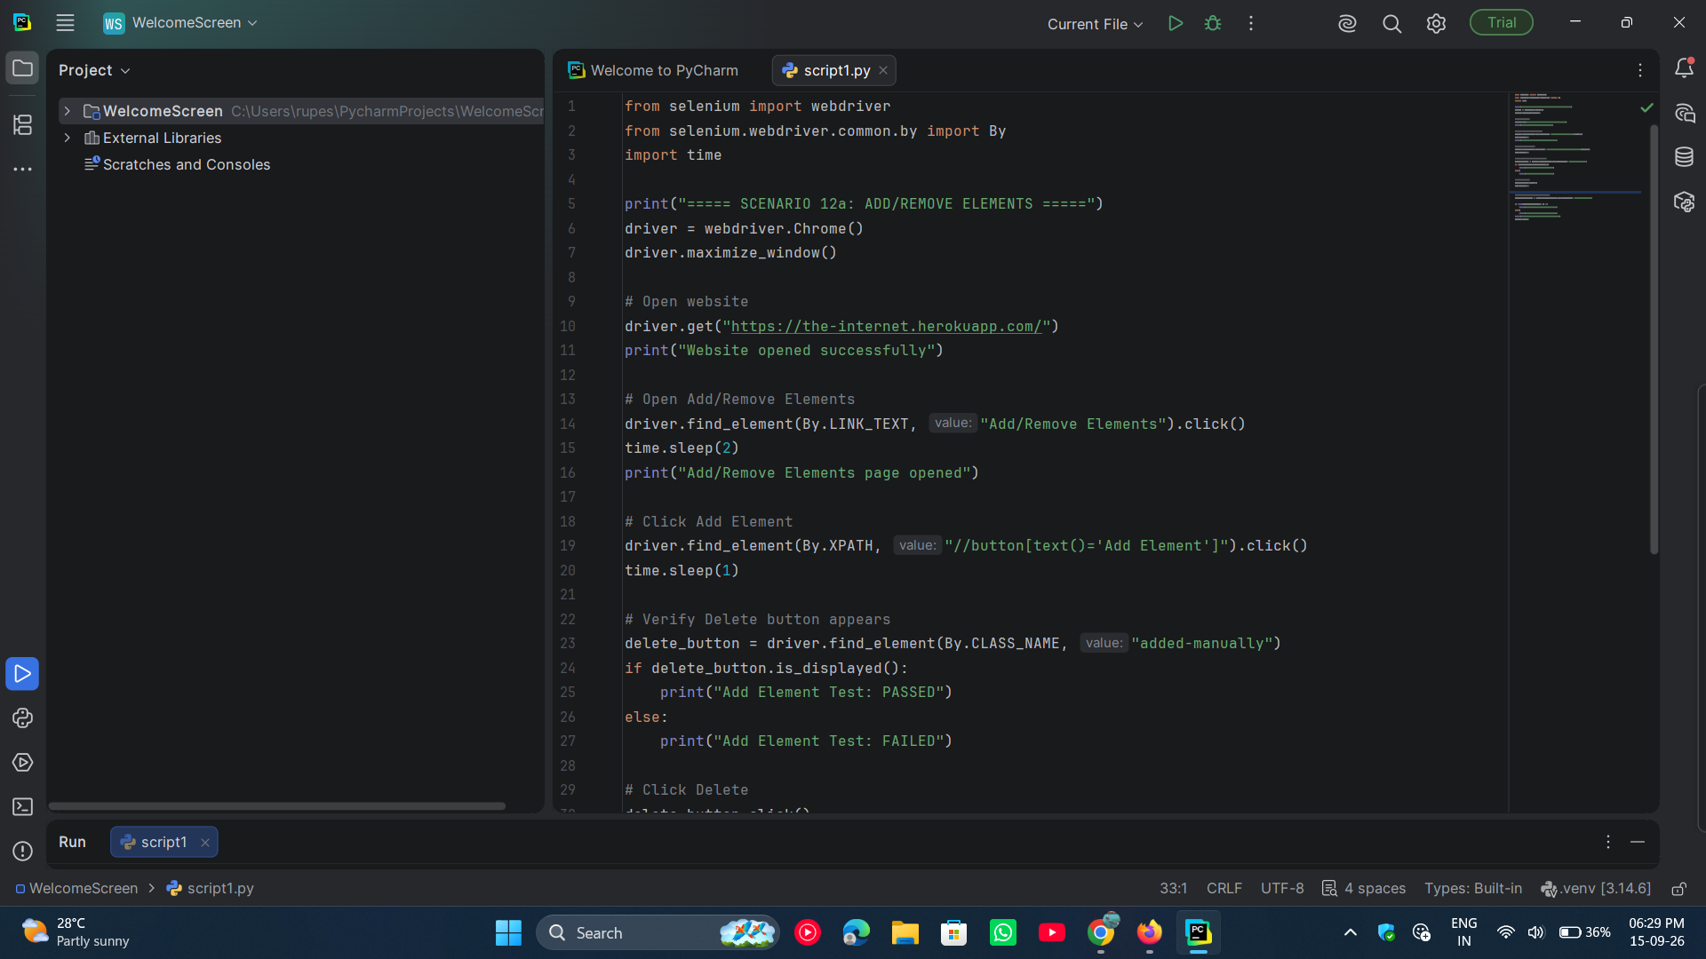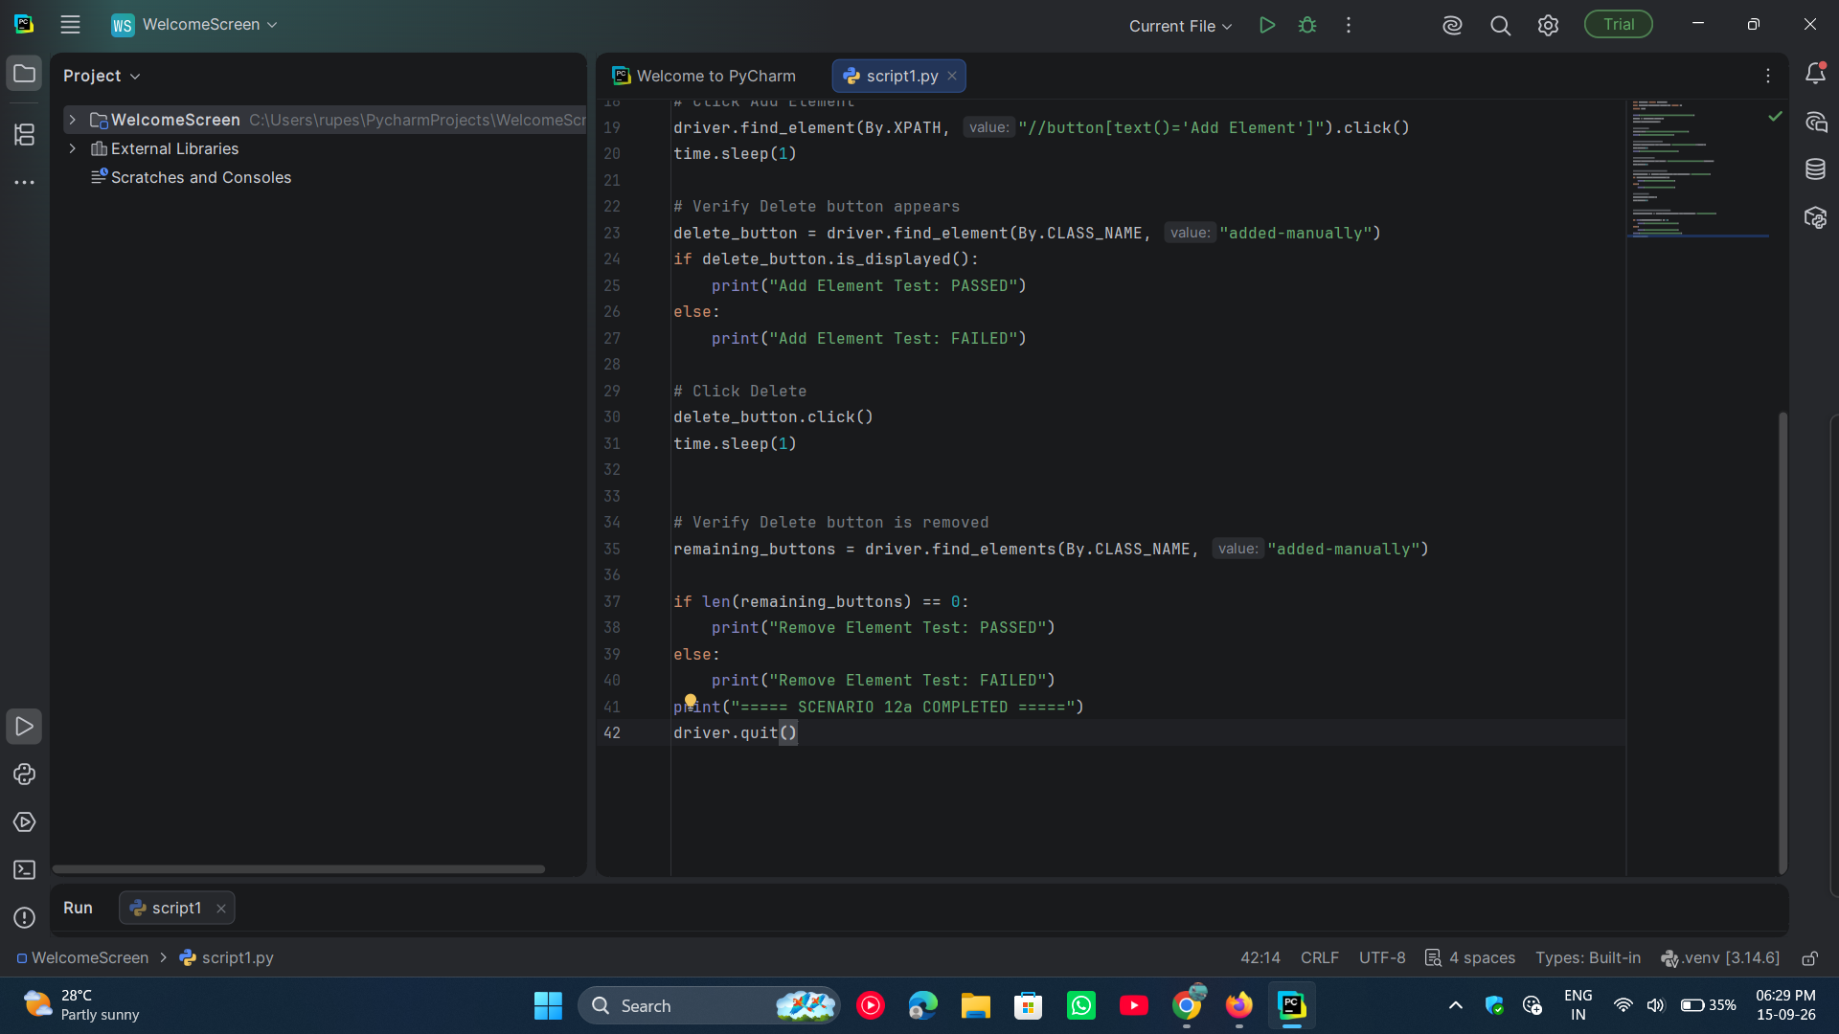
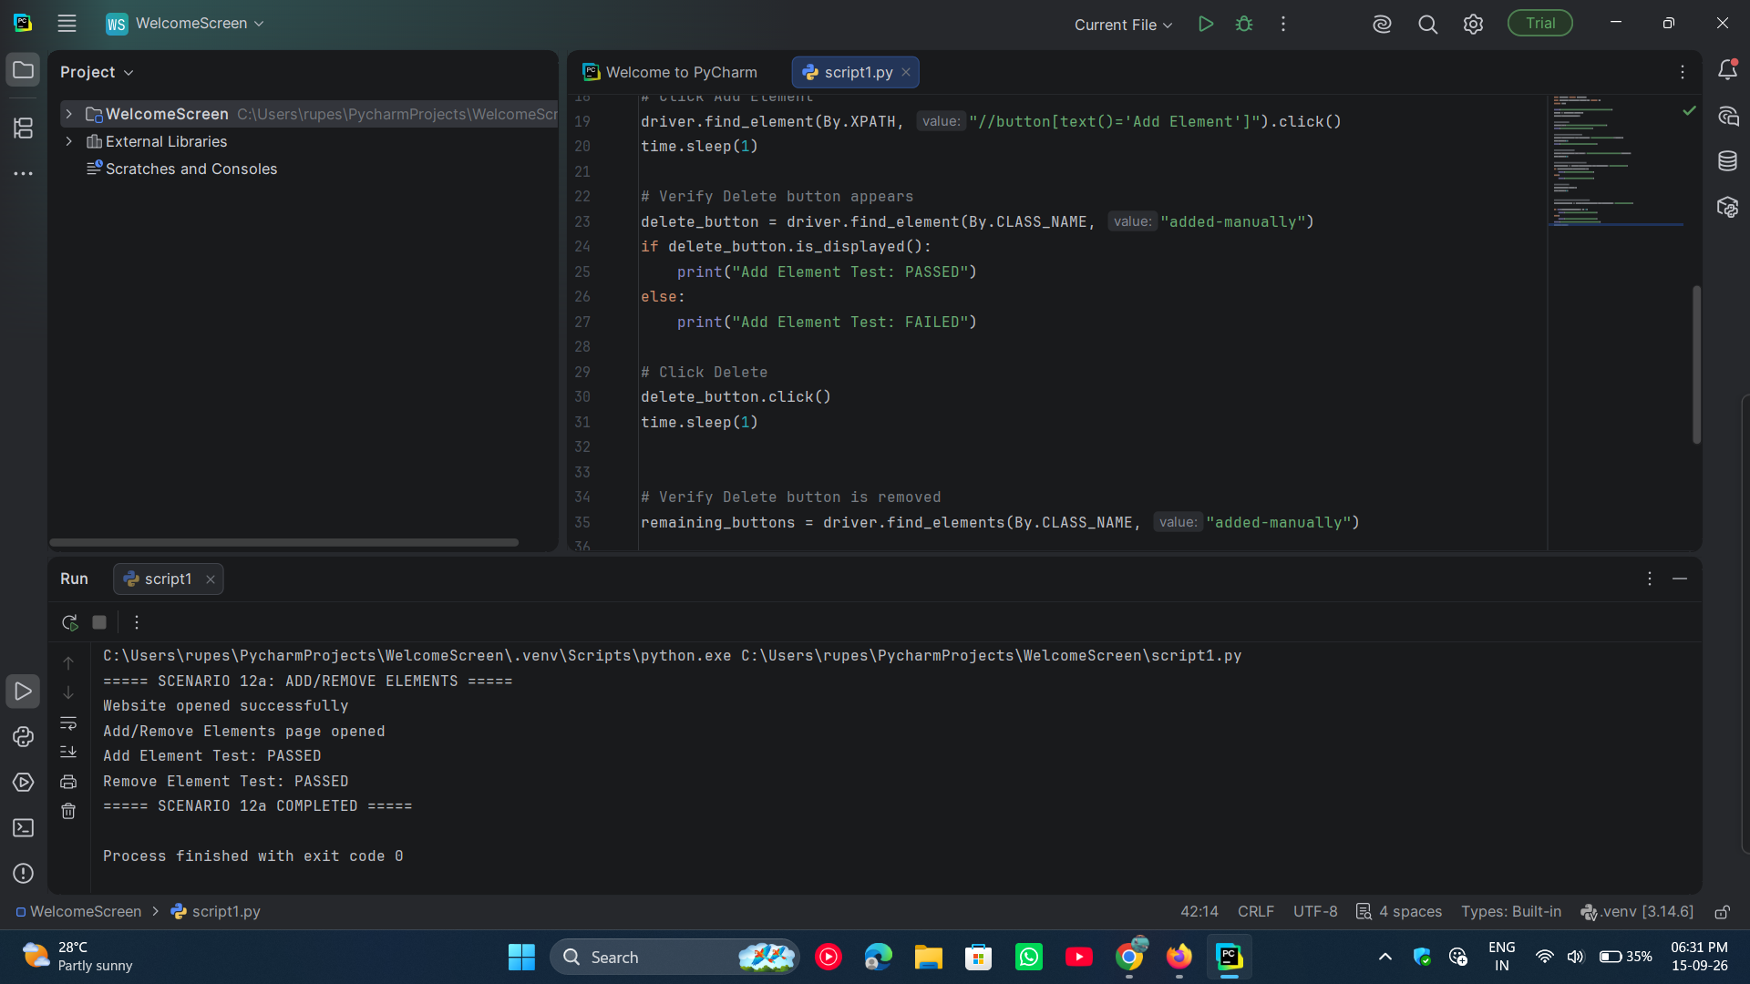

● Scenario ID: 12b
Scenario: Dynamic Loading
Test Steps:
- Open the PyCharm
- Open the existing Python automation project
- Open the Python script
- Run the Selenium automation script
- Open The Internet website
- Navigate to Dynamic Loading
- Open Example 1: Element on page that is hidden
- Click the Start button
- Wait for the element to load
- Verify that the text Hello World! is displayed
- Display the test result
- Close the browser
Screenshots: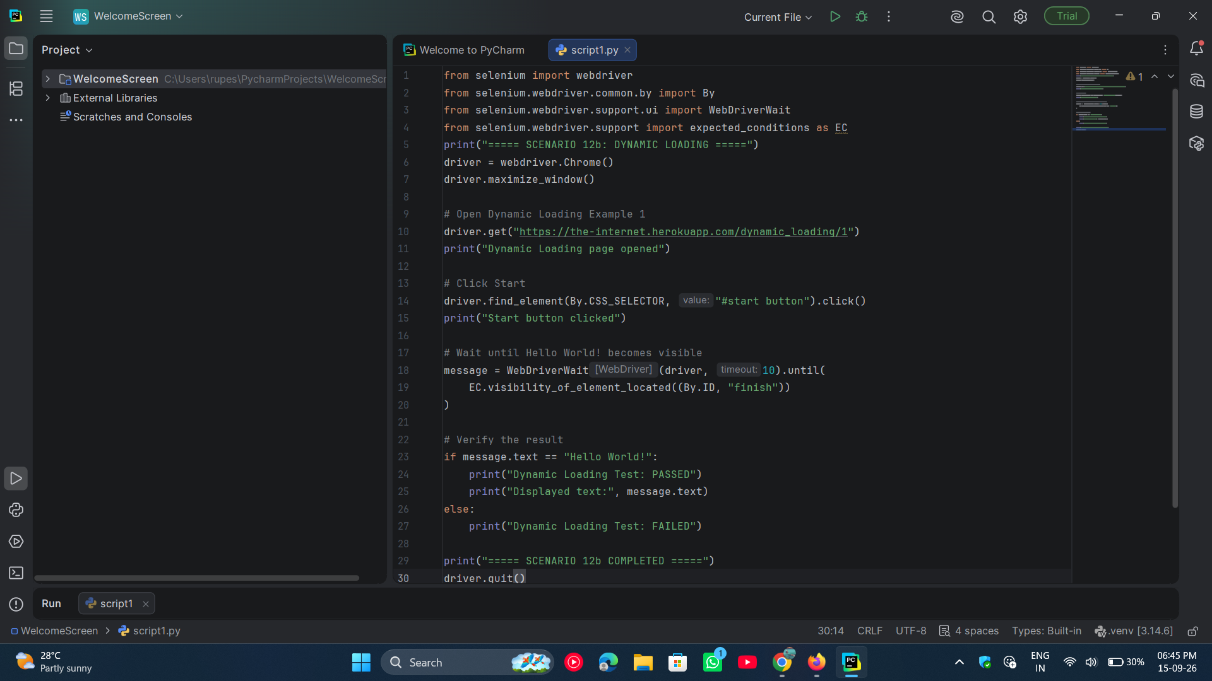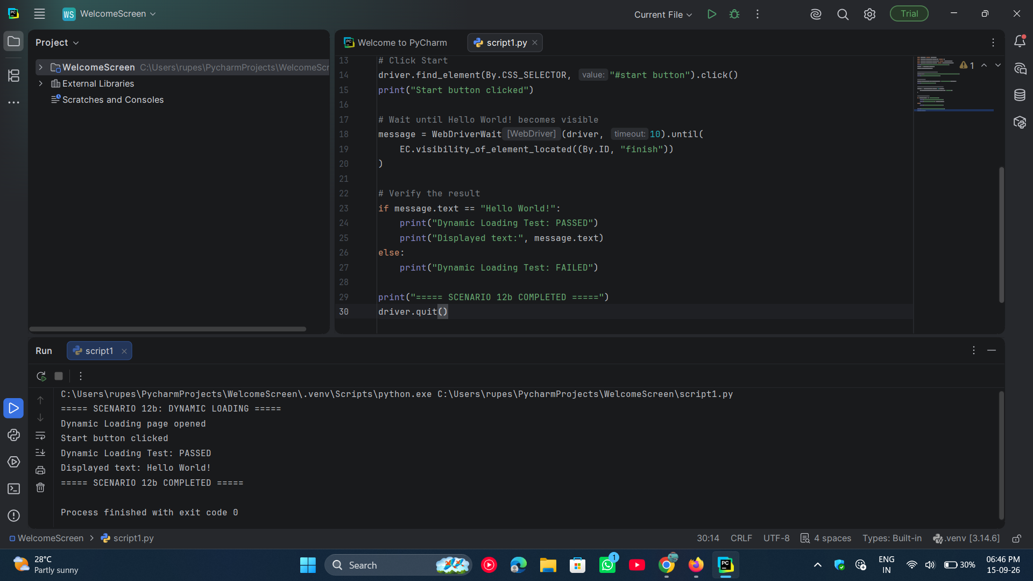

● Scenario ID: 12c
Scenario: Handling JavaScript Alerts

Test Steps:
- Open the PyCharm
- Open the existing Python automation project
- Open the Python script
- Run the Selenium automation script
- Open The Internet website
- Navigate to JavaScript Alerts
- Click Click for JS Alert
- Accept the alert
- Verify the result message
- Click Click for JS Confirm
- Accept the confirmation alert
- Verify the result message
- Display the test result
- Close the browser
Screenshots: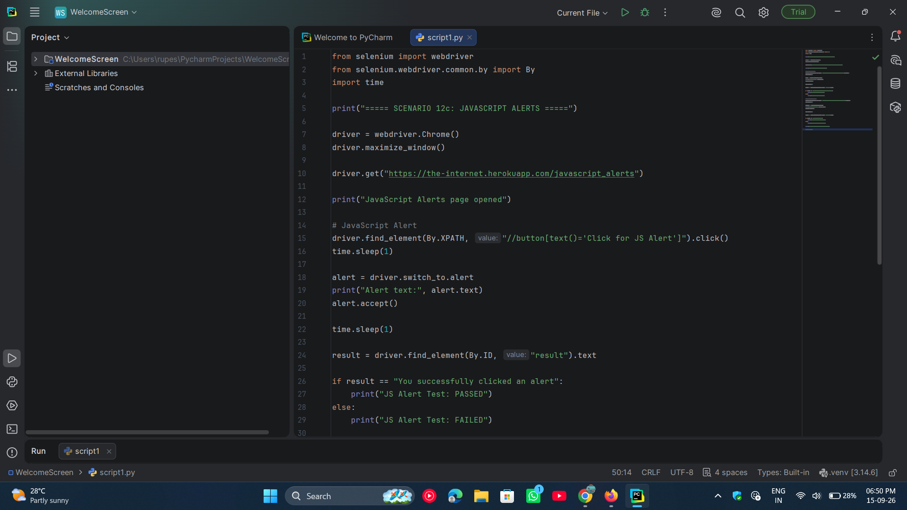

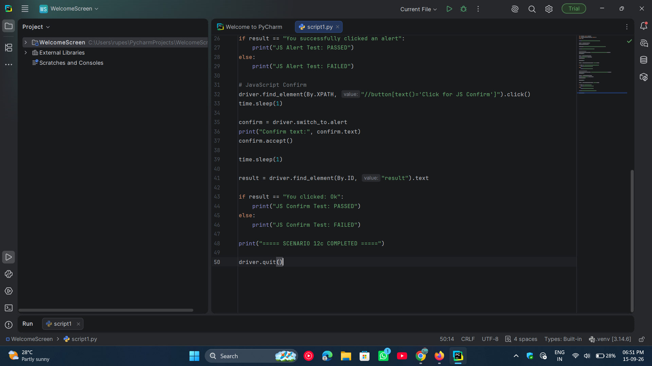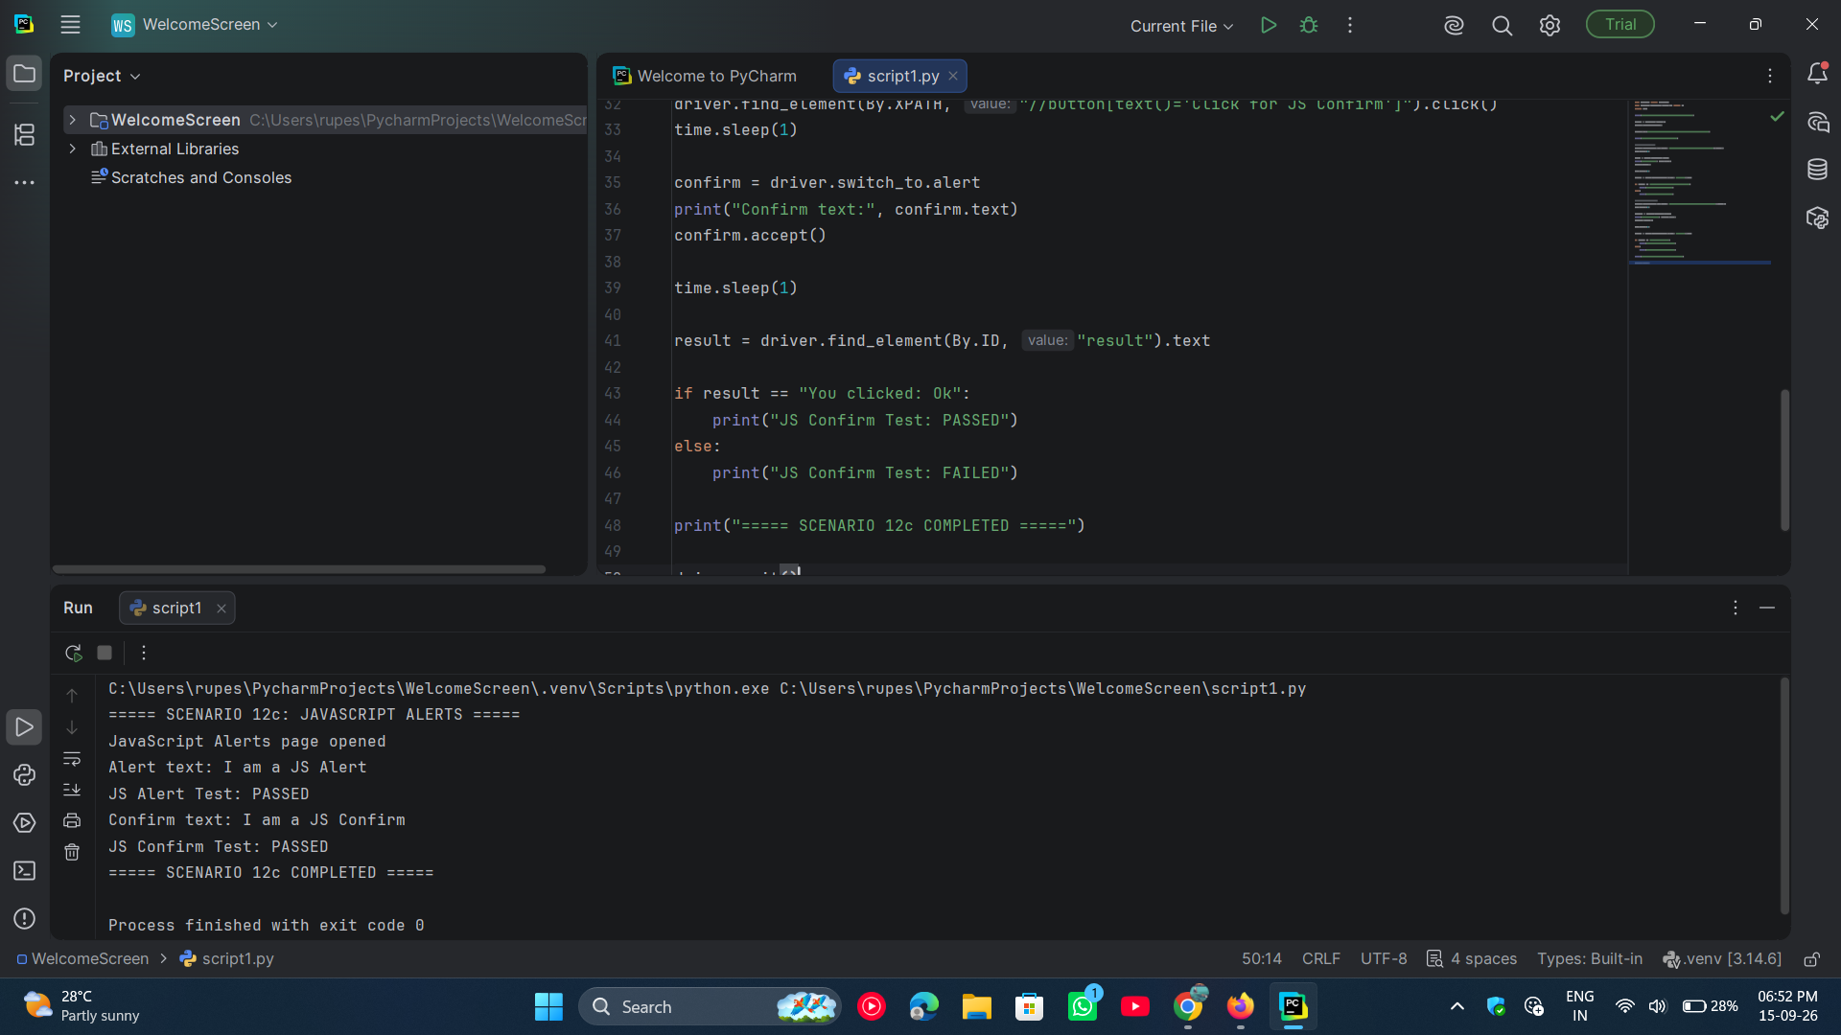

● Scenario ID: 12d
Scenario: Handling Frames
Test Steps:
- Open PyCharm
- Open the existing Python automation project
- Open the Python script
- Run the Selenium automation script
- Open The Internet website
- Navigate to Frames → iFrame
- Switch from the main webpage to the iframe
- Locate the text editor inside the iframe
- Enter text into the editor
- Verify that the text is entered successfully
- Switch back to the main webpage
- Display the test result
- Close the browser
Screenshots: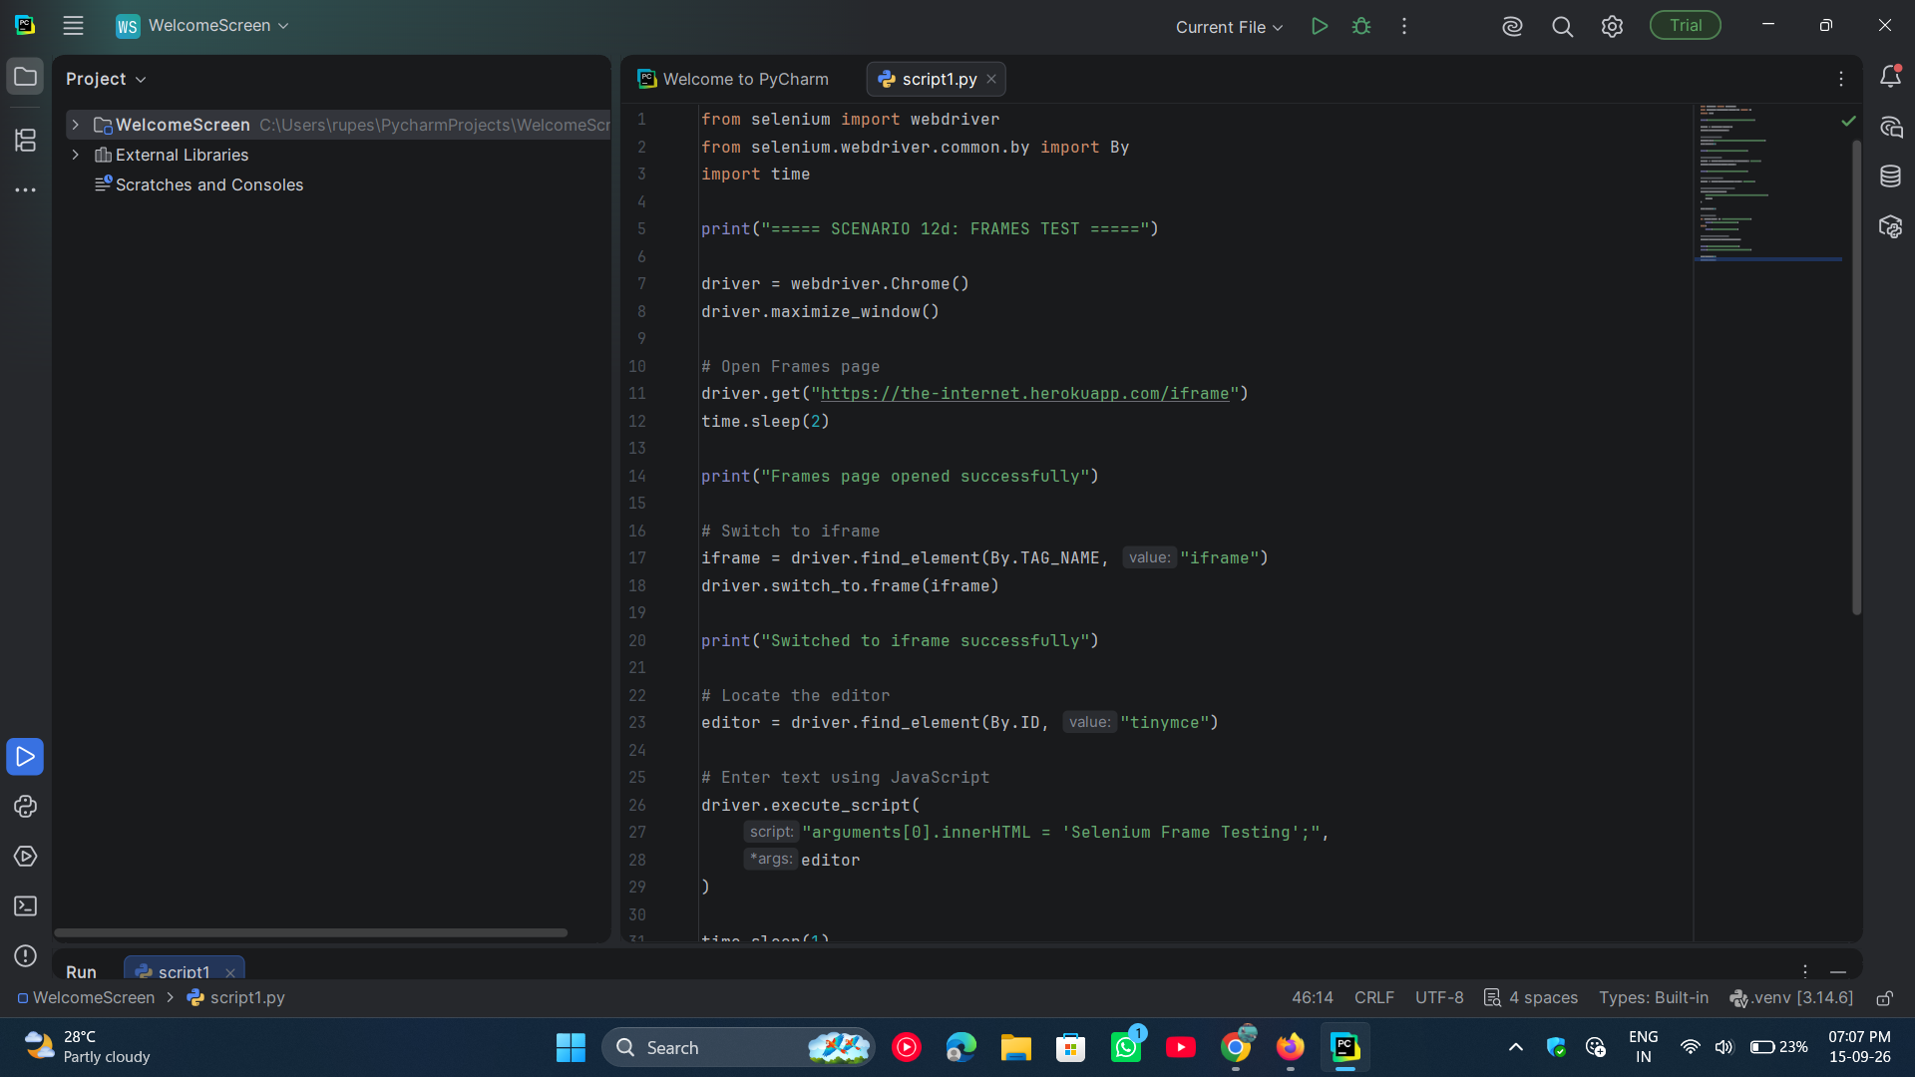

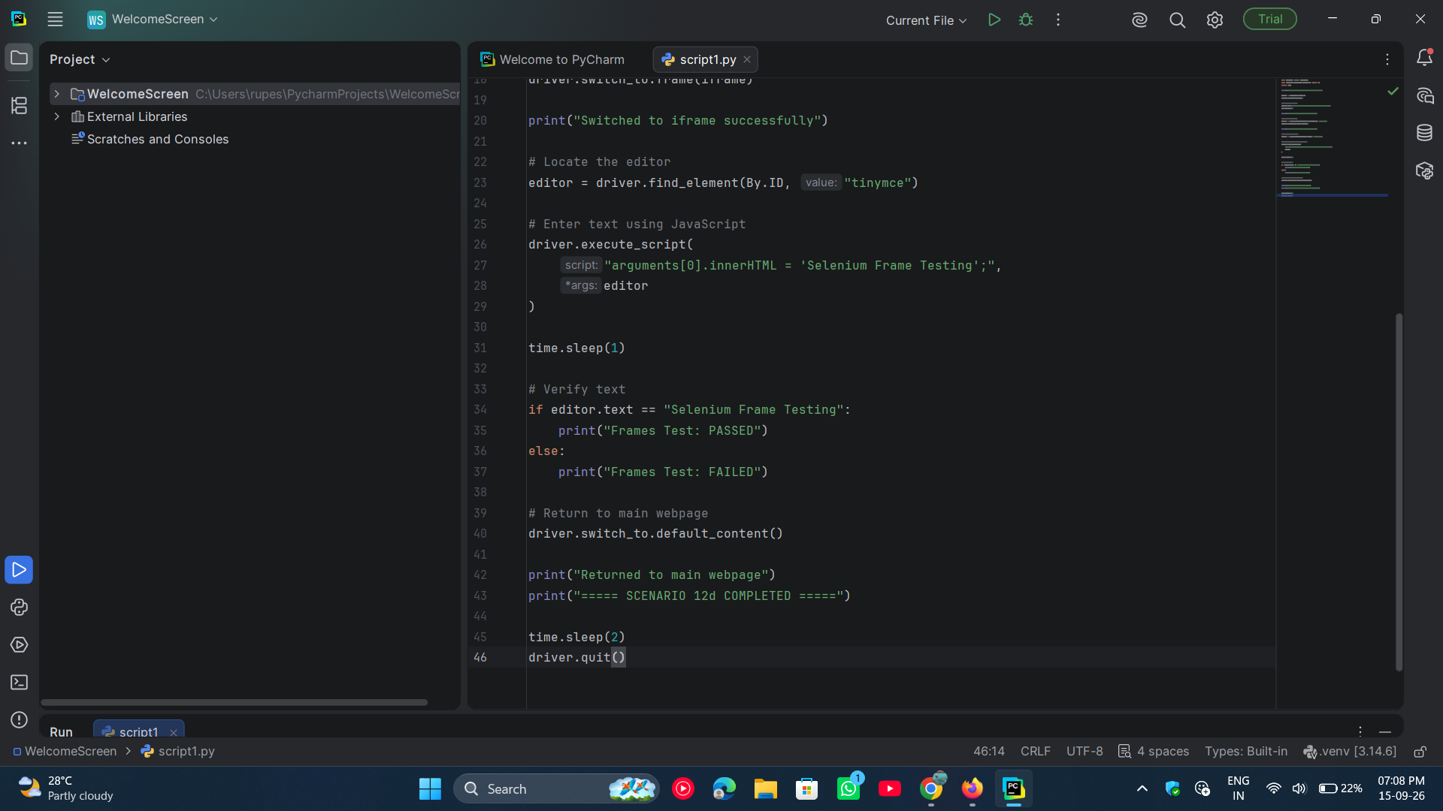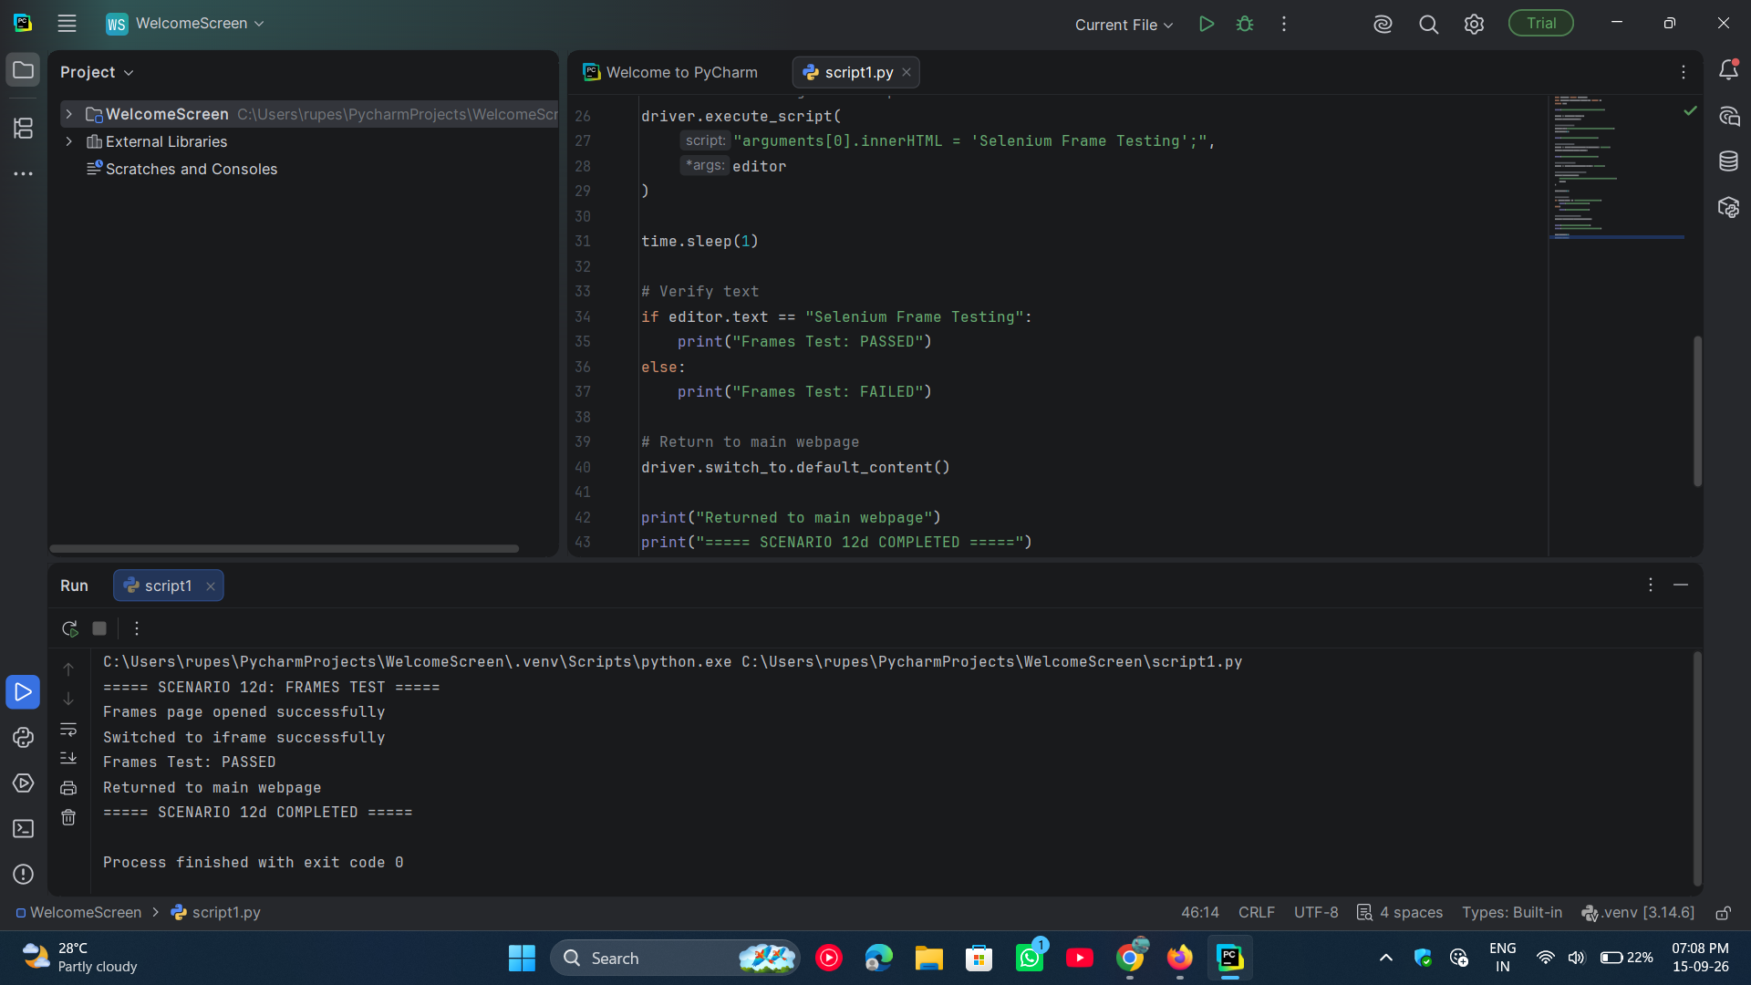

● Scenario ID: 12e
Scenario: Handling JavaScript Alerts

Test Steps:
- Open the PyCharm
- Open the existing Python project
- Open script1.py
- Run the Selenium automation script
- Open the JavaScript Alerts page
- Click Click for JS Alert
- Handle the JavaScript alert
- Accept the alert
- Verify the result message
- Display the test result
- Close the browser
Screenshots: